PROJECT REPORT
ON PROFIT ANALYSIS



Project ID: PRDA-01 Profit Analysis Team ID: PTID-CDA-JUN-26-11153

Submitted by:
Ikramul Haque Laskar P Hemanth Pavan Aditya Singh
H Vijay

ABSTRACT
The purpose of this project is to analyze the factors affecting startup profitability using Multiple Linear Regression and Business Intelligence techniques. The dataset consists of information from 50 startups located in New York, California, and Florida, including R&D Spend, Administration Spend, Marketing Spend, and Profit.
The study aims to determine how different expenditure categories influence profit and develop a predictive model capable of estimating future profits.
Multiple Linear Regression is applied to identify the relationship between independent variables and profit. Power BI is used to create interactive dashboards and visualizations that facilitate better understanding of the data.
The results indicate that R&D Spend has the strongest positive impact on profit, while Administration Spend contributes minimally. The developed regression model demonstrates high accuracy with an R² value of 0.9507. The findings provide valuable insights that can help startups optimize resource allocation and improve financial performance.

TABLE OF CONTENTS

Chapter No. | Title | Page No.
Abstract | Abstract | i
Chapter 1 | Introduction | 1
Chapter 2 | Problem Statement | 2
Chapter 3 | Objectives of the Study | 3
Chapter 4 | Methodology | 4
Chapter 5 | Data Import | 5-6
Chapter 6 | Dataset Description | 7

Chapter 7
Regression Analysis and Profit Prediction
8-10

Chapter 8 Power BI Dashboard Analysis 11-13
Chapter 9 Insights 14-15
Chapter 10 Recommendations 16-17
Chapter 11 Conclusion 18
LIST OF FIGURES
Figure No. Description Page No.
Fig 5.1 Dataset Imported into Excel 6
Fig 7.1 Regression Analysis Output 9
Fig 8.1 Power BI Dashboard 11
Fig 8.2 State vs Profit Pie Chart 11
Fig 8.3 State vs Profit Bar Chart 11
Fig 8.4 R&D Spend vs Profit Scatter Plot 12

Fig 8.5
Administration Spend vs Profit Scatter
12
Plot

Figure No. Description Page No.
Fig 8.6 Marketing Spend vs Profit Scatter Plot 13
LIST OF TABLES
Table No. Description Page No.

Table 7.1
Predicted Profit
10
Values

Chapter 1:

INTRODUCTION
In the modern business environment, startups operate under intense competition and limited financial resources. To achieve sustainable growth and profitability, organizations must carefully allocate their budgets across various operational activities. Among the most significant expenditures are Research and Development (R&D), Administration, and Marketing. Each of these activities plays a crucial role in supporting business growth; however, their individual contributions to profitability may vary.
Research and Development activities are often associated with innovation, product improvement, and technological advancement. Marketing activities focus on customer acquisition and brand awareness, while Administration expenses support daily organizational operations. Understanding how these expenditures affect profit can help organizations make informed strategic decisions.
With the increasing availability of data, organizations are increasingly adopting analytical techniques to improve decision-making processes. Regression Analysis is one such technique that enables businesses to identify relationships between variables and predict future outcomes. Combined with Business Intelligence tools such as Power BI, regression models can provide meaningful insights that support strategic planning and performance optimization.
This project focuses on analyzing startup expenditure data to understand the impact of R&D, Administration, and Marketing spending on profit. The study applies Multiple Linear Regression to build a predictive model and uses Power BI to visualize key relationships and trends within the dataset.

Chapter 2:

PROBLEM STATEMENT
Startups invest substantial amounts of money in research, administration, and marketing activities with the expectation of generating higher profits.
However, management often faces challenges in determining which investment category contributes most significantly to profitability.
Without proper analysis, organizations may allocate resources inefficiently, leading to reduced returns on investment. Therefore, it is essential to identify the key factors influencing profit and understand the relationship between business expenditures and financial performance.
The problem addressed in this study is to determine how R&D Spend, Administration Spend, and Marketing Spend affect startup profitability and to develop a predictive model that can estimate future profits based on these expenditures.

Chapter 3:

OBJECTIVES OF THE STUDY

Primary Objective
To analyze the impact of startup expenditures on profitability using Multiple Linear Regression.

Specific Objectives
- To understand the structure and characteristics of the startup dataset.
- To identify relationships between expenditure variables and profit.
- To develop a predictive regression model.
- To evaluate the performance of the model.
- To predict future profit values.
- To create Power BI visualizations for better understanding of business performance.
- To generate actionable recommendations based on analytical findings.

Chapter 4:

METHODOLOGY
The project follows a systematic analytical framework consisting of several stages.

Data Collection
The startup dataset was obtained from the provided source and imported into the analytical environment.

Data Exploration
The dataset was examined to understand variable distributions and identify relationships between features.

Data Preparation
Data quality checks were performed to ensure consistency and accuracy before model development.

Model Development
Multiple Linear Regression was applied to establish the relationship between expenditure variables and profit.

Model Evaluation
Performance metrics such as R², Adjusted R², and Significance F were used to evaluate model effectiveness.

Prediction
The developed model was used to estimate profits for new expenditure values.

Visualization
Power BI dashboards were created to support visual analysis and business interpretation.

Chapter 5:

Data Import
Microsoft Excel was used as the primary tool for data preparation, regression analysis, and profit prediction. The startup dataset was first retrieved from the database using the provided credentials and then imported into Excel for further analysis. Excel provided a convenient platform for examining the data, performing statistical analysis, and developing a predictive model to estimate profit based on startup expenditures.

Step 1: Data Import
The startup dataset was successfully retrieved from the database using the provided connection credentials. After extraction, the data was imported into Microsoft Excel, where it was organized into a structured tabular format.
Importing the dataset into Excel enabled efficient data handling and prepared the data for further analysis.

Step 2: Data Inspection and Preprocessing
Before conducting the regression analysis, the dataset was thoroughly examined to ensure its quality and reliability. Various data validation checks were performed to identify potential issues that could affect the accuracy of the analysis.
The dataset was inspected for:
- Missing or null values
- Duplicate records
- Inconsistent or incorrect data entries
- Formatting issues across columns
- Outliers or unusual observations

After careful examination, it was observed that the dataset was clean and well-structured. No significant missing values or duplicate records were found, and all variables were in an appropriate format for analysis. Therefore, only minimal preprocessing was required before proceeding with the regression analysis.
This step ensured that the dataset was accurate, consistent, and suitable for building a reliable predictive model.
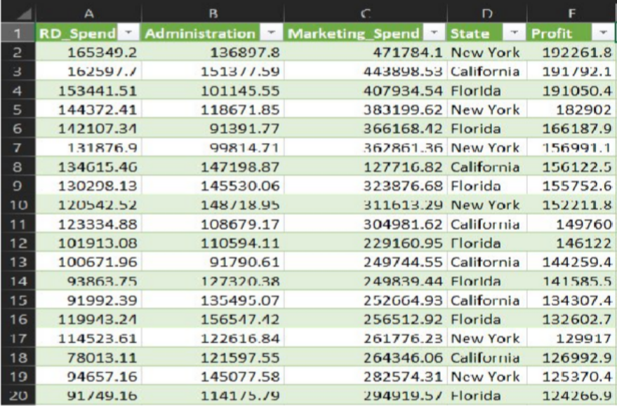
Fig 5.1

Chapter 6:

DATASET DESCRIPTION
The dataset contains information regarding 50 startups located in three different states within the United States.

Variables Included R&D Spend
Represents the amount invested in research and development activities aimed at innovation and product enhancement.

Administration Spend
Represents operational and managerial expenses incurred by the organization.

Marketing Spend
Represents expenditures related to advertising, promotion, and customer acquisition activities.

State
Categorical variable identifying the geographical location of the startup.

Profit
Represents the financial earnings generated by each startup.

Chapter 7:

REGRESSION ANALYSIS & PROFIT PREDICTION
Regression Analysis is a statistical technique used to measure the relationship between a dependent variable and one or more independent variables.

Dependent Variable
- Profit

Independent Variables
- R&D Spend
- Administration Spend
- Marketing Spend
General Multiple Regression Formula Profit = M₁X₁ + M₂X₂ + M₃X₃ + C
Obtained Regression Equation
Profit = 50122.19 + 0.8057(R&D Spend) − 0.0268(Administration Spend) + 0.0272(Marketing Spend)
The coefficients indicate the expected change in profit resulting from a one-unit increase in each independent variable while keeping other variables constant.

MODEL EVALUATION

R² Value
R² = 0.9507
This indicates that approximately 95.07% of profit variation can be explained by the model.

Adjusted R²
Adjusted R² = 0.9475
This value confirms that the model maintains strong predictive capability even after considering the number of predictors.

Significance F
Significance F = 4.53 × 10⁻³⁰
This extremely small value confirms that the regression model is statistically significant.
Overall, the evaluation metrics indicate that the model provides excellent predictive performance.
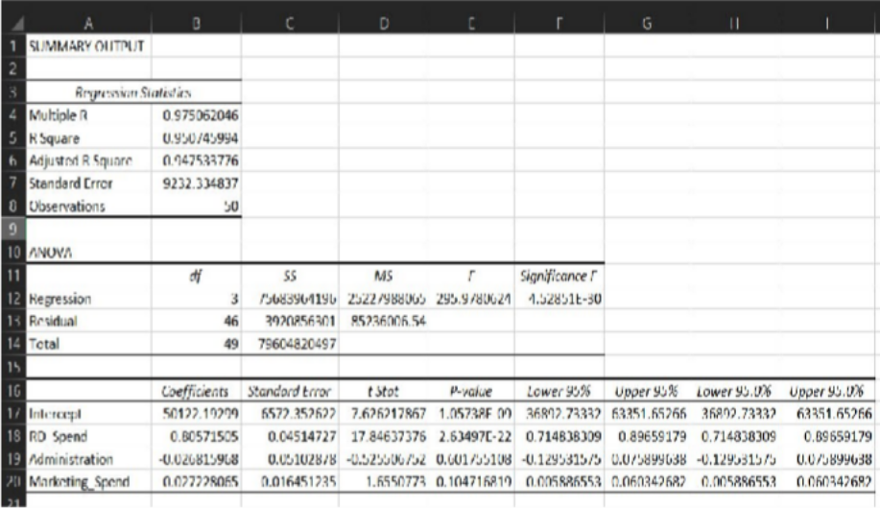
Fig 7.1

Profit Prediction
After developing the Multiple Linear Regression model, the obtained regression equation was used to predict profit for the given input values of R&D Spend, Administration Spend, and Marketing Spend. The prediction process demonstrates the practical application of the model in estimating future profitability based on planned expenditures.

The predicted profit values are shown below:

R&D Spend
Administration Spend
Marketing Spend

Profit
Predicted

21,892.92 81,910.77 164,270.70 70,037.90
23,940.93 96,489.63 137,001.10 70,554.57
Predicted Profit Values

The results indicate that both startups are expected to generate profits of approximately ₹70,000. Although the second startup has a lower marketing expenditure, its higher R&D investment contributes to a slightly higher predicted profit. This further supports the findings of the regression analysis, which identified R&D Spend as the most significant factor influencing profitability.
These predictions demonstrate the usefulness of the regression model as a decision-support tool, enabling organizations to estimate future profits and evaluate different spending strategies before making investment decisions.

Chapter 8:

POWER BI DASHBOARD ANALYSIS

Dashboard
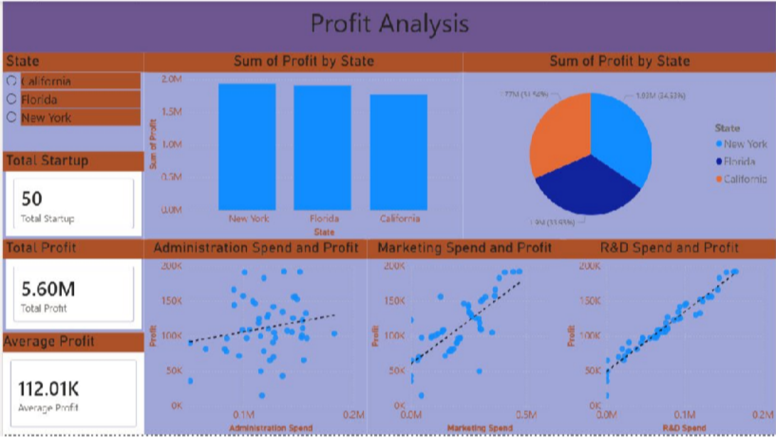
Fig 8.1

State vs Profit Bar Chart and Pie Chart
The bar chart compares profit across different states and highlights geographical differences in startup performance.
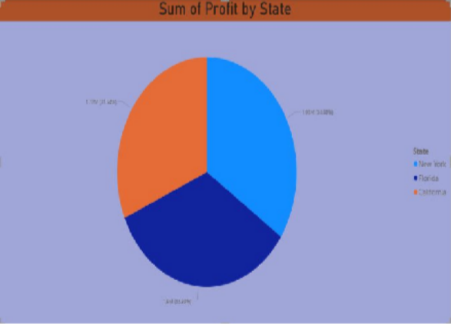
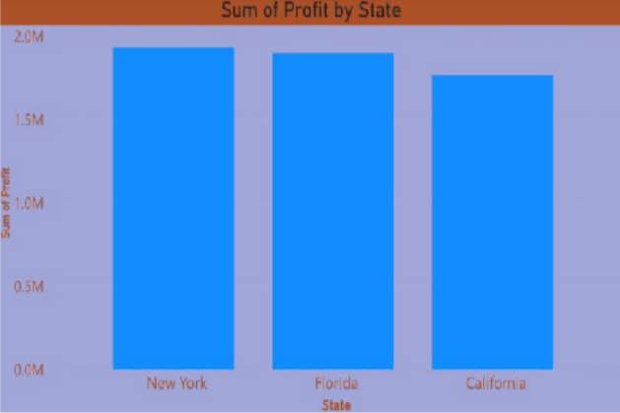
Fig 8.2 Fig 8.3

R&D Spend vs Profit Scatter Plot
A strong positive trend is observed, indicating that increased investment in R&D is associated with higher profitability.
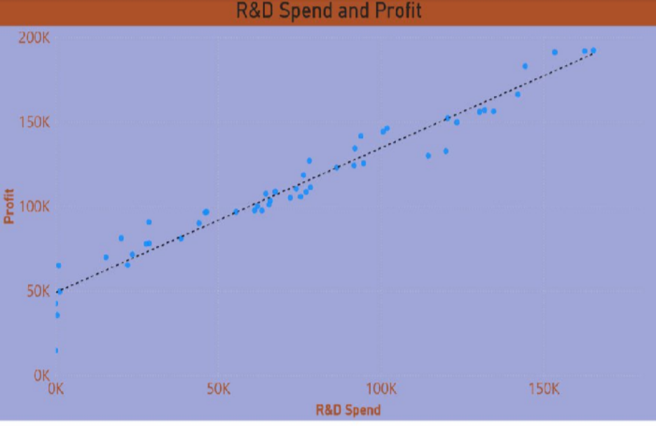
Fig 8.4

Administration Spend vs Profit Scatter Plot
The relationship between administration spending and profit appears relatively weak, suggesting limited impact.
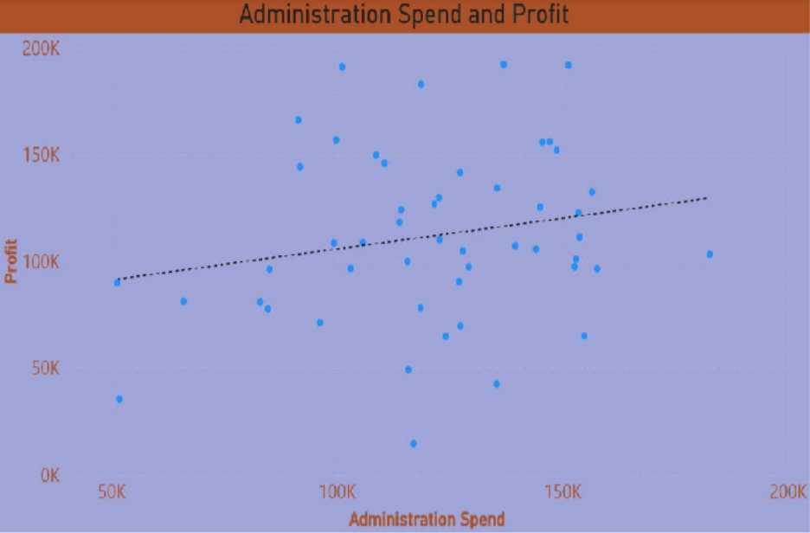
Fig 8.5

Marketing Spend vs Profit Scatter Plot
A positive relationship exists between marketing expenditure and profit; however, the impact is less pronounced than R&D spending.
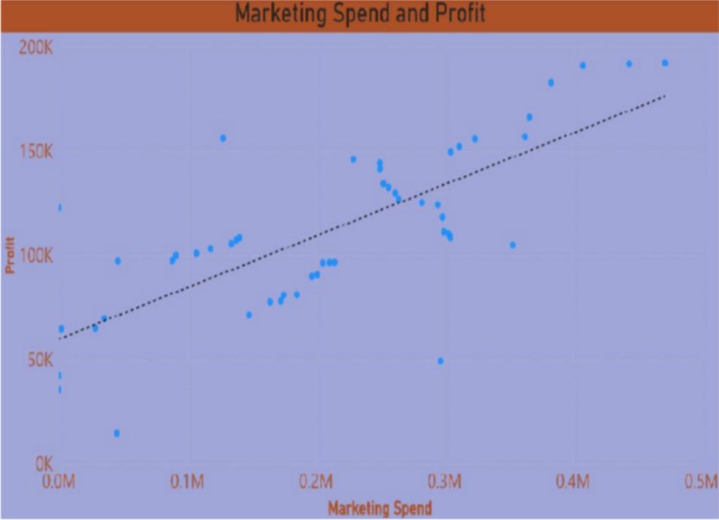
Fig 8.6

Chapter 9:

INSIGHTS

R&D Spend is the Strongest Driver of Profit
The regression analysis revealed that R&D expenditure has the highest positive coefficient among all independent variables. This indicates that startups investing more in research and development activities tend to achieve significantly higher profits. Investments in innovation, product enhancement, and technological advancement directly contribute to improved business performance and competitive advantage.

Marketing Spend Positively Influences Profit
Marketing expenditure demonstrates a positive relationship with profit, suggesting that promotional activities and customer acquisition strategies contribute to revenue growth. However, the impact of marketing spending is considerably lower than that of R&D spending. This suggests that while marketing remains important, excessive marketing expenditure without a strong product foundation may not yield maximum returns.

Administration Spend Has Limited Impact on Profitability
The regression results indicate that administration spending has a negligible and statistically insignificant effect on profit. This suggests that increasing administrative expenses alone does not necessarily improve business performance. Efficient management of operational costs is therefore essential for maintaining profitability.

Strong Predictive Performance of the Model
The regression model achieved an R² value of 0.9507, indicating that approximately 95% of the variation in profit can be explained by the selected variables. This demonstrates that the model is highly reliable and can be effectively used for forecasting and decision-making purposes.

Geographical Differences Exist Among Startups

The State vs Profit visualization highlights differences in profitability across states. California startups generated the highest overall profit, indicating that regional factors such as market conditions, access to resources, and business ecosystems may influence startup performance.

Data-Driven Decision Making Improves Business Efficiency
The successful application of regression analysis and Power BI demonstrates the value of analytical tools in business decision-making. Organizations can use similar approaches to identify key performance drivers and optimize resource allocation.

Chapter 10:

RECOMMENDATIONS

Increase Investment in Research and Development
Since R&D spending has the strongest positive impact on profit, startups should allocate a larger portion of their budget toward innovation, product development, and technological advancement. Continuous innovation can improve customer satisfaction and create a sustainable competitive advantage.

Focus on High-Value Innovation Projects
Organizations should prioritize R&D projects with strong market potential and measurable business value. Investing in targeted innovation initiatives can maximize returns while minimizing unnecessary expenditure.

Optimize Administrative Costs
Administrative expenses should be regularly reviewed to identify inefficiencies and eliminate unnecessary costs. Since administration spending has minimal influence on profitability, organizations should focus on maintaining operational efficiency without excessive expenditure.

Implement Performance-Based Budgeting
Companies should allocate budgets based on measurable outcomes and expected returns. Departments that demonstrate higher contributions to profitability should receive greater investment support.

Maintain Strategic Marketing Investments
Marketing activities should continue to support customer acquisition and brand awareness. However, marketing budgets should be optimized through performance measurement and return-on-investment analysis to ensure efficient utilization of resources.

Adopt Data-Driven Decision Making
Management should utilize analytical tools such as regression models and business intelligence dashboards to support planning and resource allocation decisions. Data-driven strategies reduce uncertainty and improve organizational performance.

Leverage Predictive Analytics for Financial Planning
The regression model can be incorporated into future planning processes to estimate expected profits under different spending scenarios. This can help management evaluate investment strategies before implementation.

Chapter 11:

CONCLUSION
The project successfully examined the relationship between startup expenditures and profitability using Multiple Linear Regression. The developed model demonstrated excellent performance with an R² value of 0.9507, indicating that the selected variables explain most of the variation in profit.
The analysis revealed that R&D Spend is the most important factor influencing startup profitability, while Marketing Spend has a moderate positive impact and Administration Spend contributes minimally. The Power BI visualizations further validated these findings by illustrating the relationships between spending patterns and profit.
The study demonstrates how predictive analytics and business intelligence tools can support data-driven decision-making. Organizations can improve profitability by prioritizing R&D investments, optimizing operational costs, and leveraging analytical insights for strategic planning.

